Use of a Token Economy to Increase Running on Command
Of a Child with Down syndrome
Brooke R. Mize
Texas Woman’s University

Abstract:
Children with Down syndrome typically have increased behavioral issues associated with their disability due to the disabilities’ phenotype. Introducing a token economy system was proven effective to increase the amount of running in the subject. The purpose of this study was to determine the effectiveness of a token economy to increase running on command of a child with Down syndrome. Having a token economy system in place, allows better stability and repetitiveness in their daily lives. This essentially helps the student maintain behavioral control and the maladaptive behaviors are less likely to happen. A five week token economy behavioral program was implemented and included earning tokens (up to five) per session to exchange for up to five minutes of computer time. The results drastically changed from pre-intervention to post-intervention by 80%. Every task was completed and when asked, although there were still minor reoccurring behaviors that needed correction. When implementing a token economy it is still important to manage the smaller behaviors in order to increase the amount of physical activity completed per session.

Introduction:
Children with Down syndrome are at an increased risk for behavioral issues due to factors including characteristics associated with the Down syndrome phenotype, increased incidence of illness, sleep disorders and the environment (McConnell, 1992). Already having underlying biophysical behavioral issues, students with Down syndrome could benefit from having a token economy in place. Token economy systems are a delayed method of reinforcement (French, 2006). In such a system, individuals receive a token immediately following successful performance of the desired behavior and later exchange the tokens for a “reinforcer” (French, 2006). Students can enter a token economy program due to their deficits of adaptive behaviors and/or excesses of maladaptive behaviors (Guevremont, 2010). In the student’s natural environments, adaptive behaviors were not reinforced, but maladaptive behaviors were (Guevremont, 2010). So, the use of the token economy reverses these reinforcement contingencies and often results in impressive (positive) changes (Guevremont, 2010).
The token economy has been proven to be successful in education based goals such as arithmetic and language (Dalton, 1973). Also, when the same students were retested later, the token economy system helped students maintain their gains in the two subjects (Dalton, 1973). In this study, we are going to look at the effectiveness of a token economy system in Adapted Physical Education. This will allow the subject more stability in the locomotor aspect of the lesson to allow for more adapted physical education during each session.

Purpose:
The purpose of the field-based single subject is to determine the effectiveness of a token economy to increase running on command of a child with Down syndrome.

Methods & Procedures:
Participant:
Student is a ten-year-old female who is an active student. She also loves pippy long stocking, Barbie, and computer time.
Study Design:
The participant attends a 20 minute direct adapted physical education class once a week.
A five week token economy was implemented and evaluated once a week during the adapted physical education class and followed an “AB” single-subject design.
Procedures:
- Escort the participant from her class to the hallway where the activities are performed.
- Have student warm up by stretching prior to running, allowing the student to choose two out of three different stretches.
- Have student run a distance of 30 feet (prior to intervention, collect at least three baseline points)
- Introduce the intervention (token economy).A reinforcement menu will be used where the child can see it while performing the task. The amount of computer time will be the reinforcer and the amount of minutes (up to 5 minutes) will be based on the amount of stickers she earns each session. Have the student sit down on the floor and explain how she can earn computer time. Her chart contains five open spots per week for five weeks. The open spots that the student can earn stickers on are: a) Positive work on a skill (this would be all skills that are requested of her to do that day) b) run 30 feet when instructed c) run 30 feet when instructed d) run 30 feet when instructed e) following directions. The order of the tasks are a) stretching, b) positive work on a skill, c) run 30 feet d) positive work on a skill, e) run 30 feet, f) positive work on a skill, g) run 30 feet, h) speak with the student regarding if she followed directions or not. The student will earn 1 minute of computer time for every sticker (up to 5) that she earns. This is reinforced prior to every activity so she knows. The student chooses from two types of stickers that are provided and places them on her.
- Have student start by working on a skill such as dribbling or striking. These are both goals on her IEP, but the student also enjoys the activities prior to running.
- Ask the student to run the 30 ft. (if run is completed, student will earn a sticker). 30ft was chosen as the length of the run because it is the length of the hallway in which the activities are performed.
- Next, have the student work on a different skill such as striking or dribbling, which are both on her IEP and she enjoys working on them as well.
- Then, have student run 30 ft (if run is completed, student will earn a sticker)
- Have the student choose her favorite skill that was worked on in the daily lesson and ask her to perform them again. (She earns a sticker for 3 skills if the skills are all completed as well as 3 stickers for each of the three runs)
- Have the student run, again, the 30ft. (will receive another sticker)
- Speak with student (closure) and evaluate if the last sticker was earned for following directions.
- There will be three data points/ per session with student. A) Run 1 between the first skill and second skill performed, b) run 2 between the second skill and third skill performed, c) run three after the third skill is performed.

Results/Conclusions:
During the first three weeks (A phase), the student demonstrated off task behavior by not running when instructed to do so. Six runs were asked of the student to complete during the A phase however, zero were completed resulting in 0%. After these findings, a token economy was implemented the first week of the intervention and continued this same process for five weeks. During the second week (B phase), results showed a 100% increase in the runs (Table 1) and an 80% increase on the behavior chart (Table 2).
The results stayed constant throughout the entirety of the five weeks. The percentage of runs stayed at 100% and the results of the behavior chart stayed at a constant 80%. There were small behavioral issues that were noted when asked to “follow directions”. This is also the reason that the subject never reached 100% on the behavioral chart.
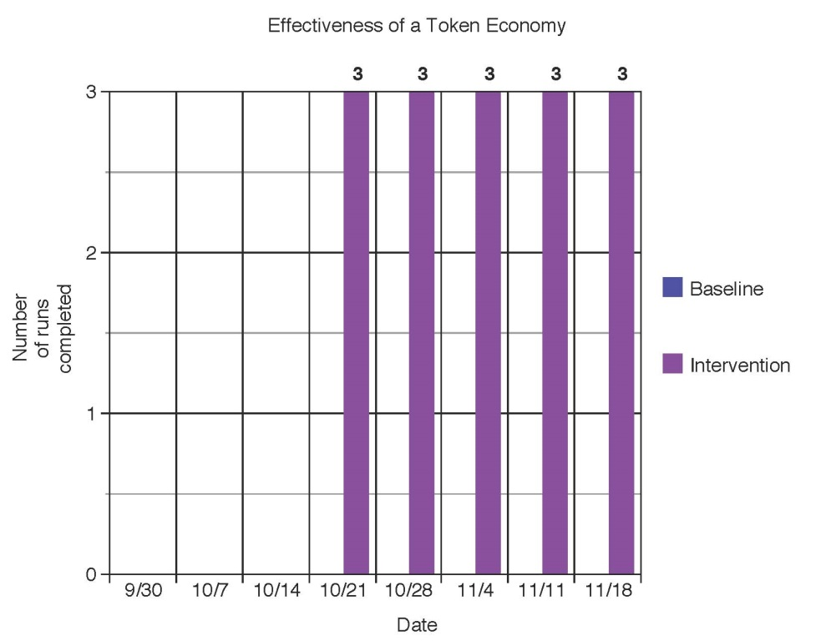
Table 1: Effectiveness of a Token Economy
Table 2: Results from Behavior Chart

Discussion:
Table 2
Children with Down syndrome are at an increased risk for engaging in challenging behavior (McConnell, 1992). So, having a token economy in place could help alleviate the behavioral issues associated with Down syndrome and allow for more physical activity time for the student. As stated earlier, token economies have been shown to be effective when used in a general education setting, concluding that these same systems could be effective in physical education settings (Alstot, 2012). Token economies would be effective in physical education settings because they are known to: decrease problem behaviors, improve skill acquisition, and increase other appropriate physical activity behaviors (Alstot, 2012). When utilizing the running chart in place, the subject proved that the token economy was effective in the physical education setting because her running dramatically increased.
Although children with Down syndrome are very unique, there is still an underlying phenotype that creates the same issues throughout the disability. So, having any type of behavior management plan for a child with Down syndrome is strongly recommended, and with this subject the token economy was proven effective. It is important to have a structured and well-rounded environment for the student to be most successful in. Having a behavior plan in place prior to working with the student could potentially save a great deal of time. This could allow for more physical activity for the student to be successful in.

References
Alstot, A.E. (2012). Implications for the Use of Token Economies in Physical Education: A Literature Review. PHEnex, 4(1). Retrieved from http://ojs.acadiau.ca/index.php/phenex/article/view/1449.
Dalton, A.J., Hislop, M.W., & Rubino, C.A. (1973). Some Effects of Token Rewards on School Achievement of Children with Down syndrome. Journal of Applied Behavior Analysis, 6(02), 251-259.
French, R., Henderson, H.L., & Lavay, B.W. (2006). Positive Behavior Management in Physical Activity Settings 2nd Edition. Champaign, IL: Human Kinetics.
Guevremont, D.C., & Spiegler, M.S. (2010). Contemporary Behavior Therapy 5th Edition. Wadsworth, CA: Cengage Learning.
McConnell, S.R. & Strain, P.S. (1992). Behaviorism in Early Intervention. Topics in Early Childhood Special Education, 12(01), 121.

